HW3 Yaroslav Popryho

ypopry2@uic.edu

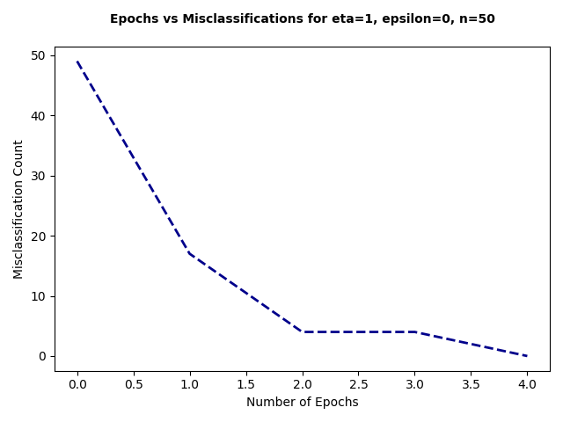

**Executing Configuration F:**

* Percentage of misclassified test samples: 45.6%

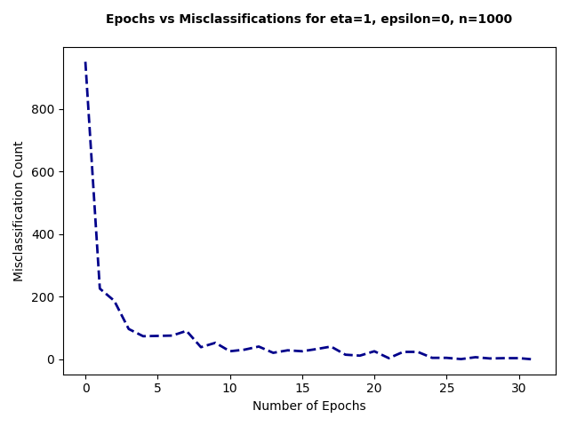

**Executing Configuration G:**

* Percentage of misclassified test samples: 17.8%

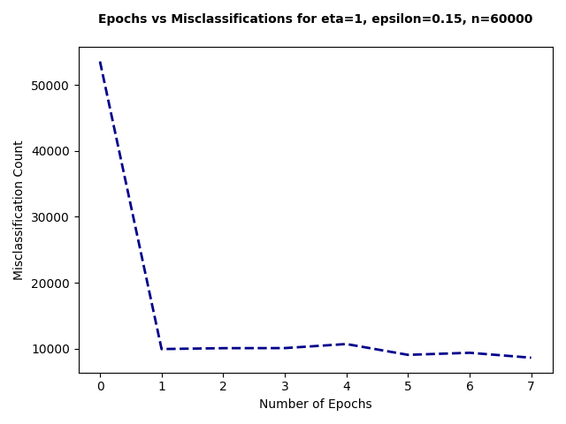

**Executing Configuration H:**

* Percentage of misclassified test samples: 17.02%

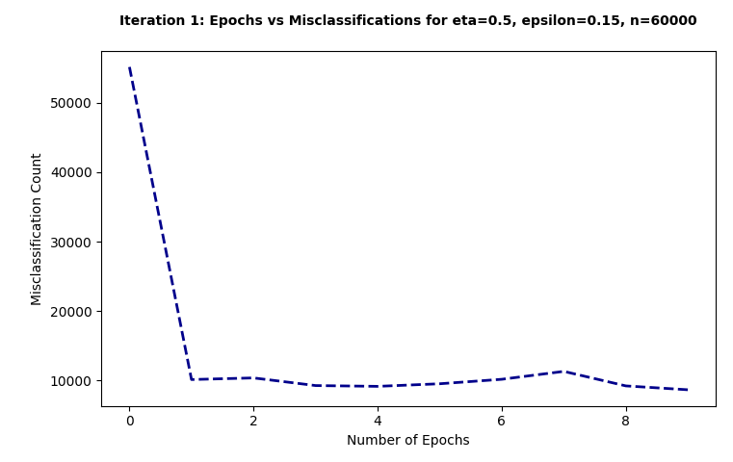

**Executing Configuration I Iteration 1:**

* Percentage of misclassified test samples: 17.97%

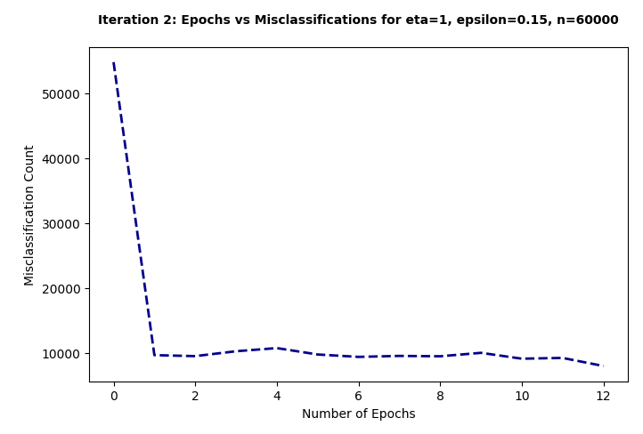

**Executing Configuration I Iteration 2:**

* Percentage of misclassified test samples: 17.94%

**Executing Configuration I Iteration 3:**

* Percentage of misclassified test samples: 14.51%

### Observations and Discrepancies:

* **Overfitting:** If the model demonstrates 0% error during training but exhibits a high error rate during testing, it is indicative of overfitting to the training data.
* **Data Variability:** Discrepancies in error rates may also arise due to differences between the training and testing datasets.
* **Model Complexity:** A model that is too simplistic may fail to encapsulate all the intricacies of the data, leading to discrepancies in error rates.
* **Increased Training Data:** Enhancing the quantity of training data (n) might result in improved generalization and a decrease in discrepancies between training and testing error rates, but this is effective only up to a certain threshold.